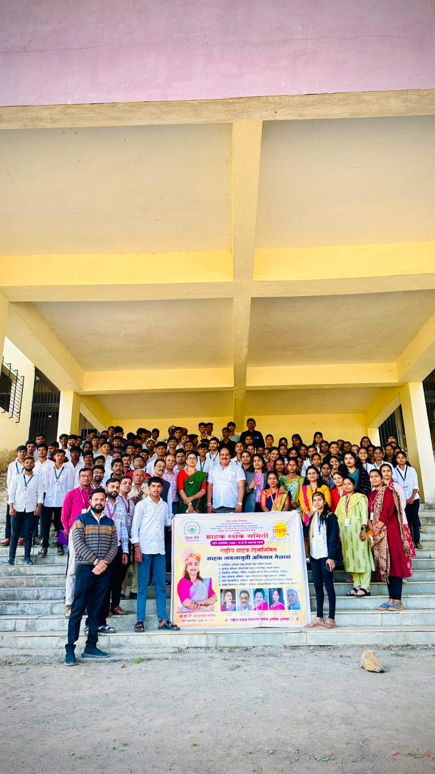

GRAHAK DIN CELEBRATION

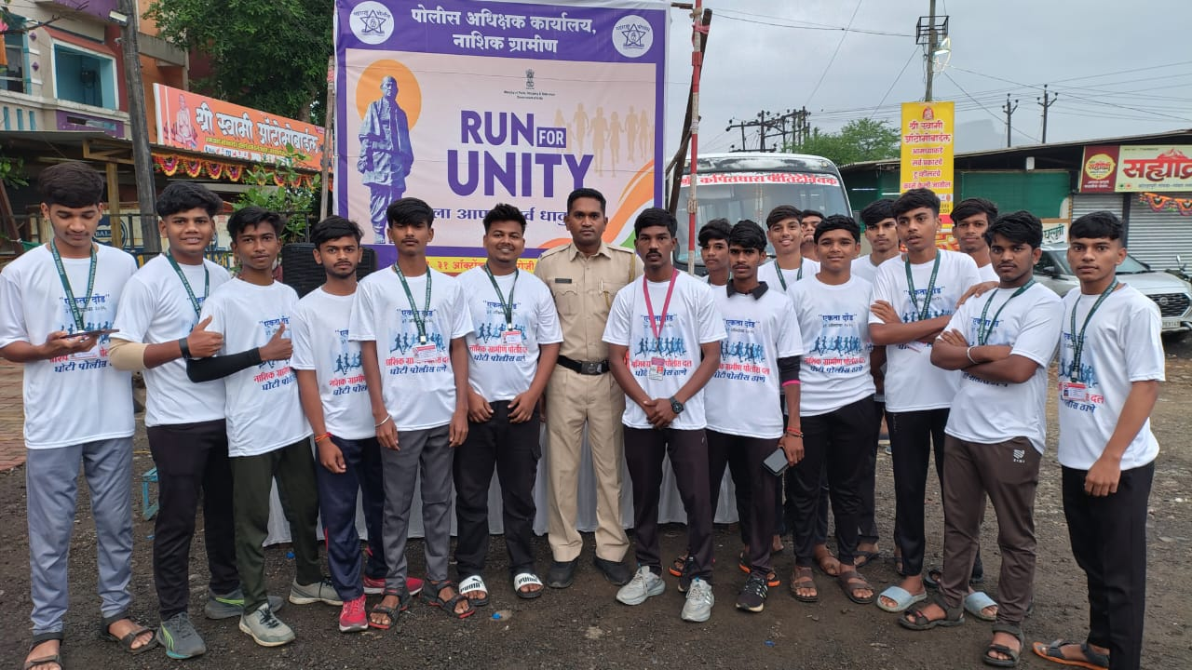

RUN FOR UNITY POLICE DAY

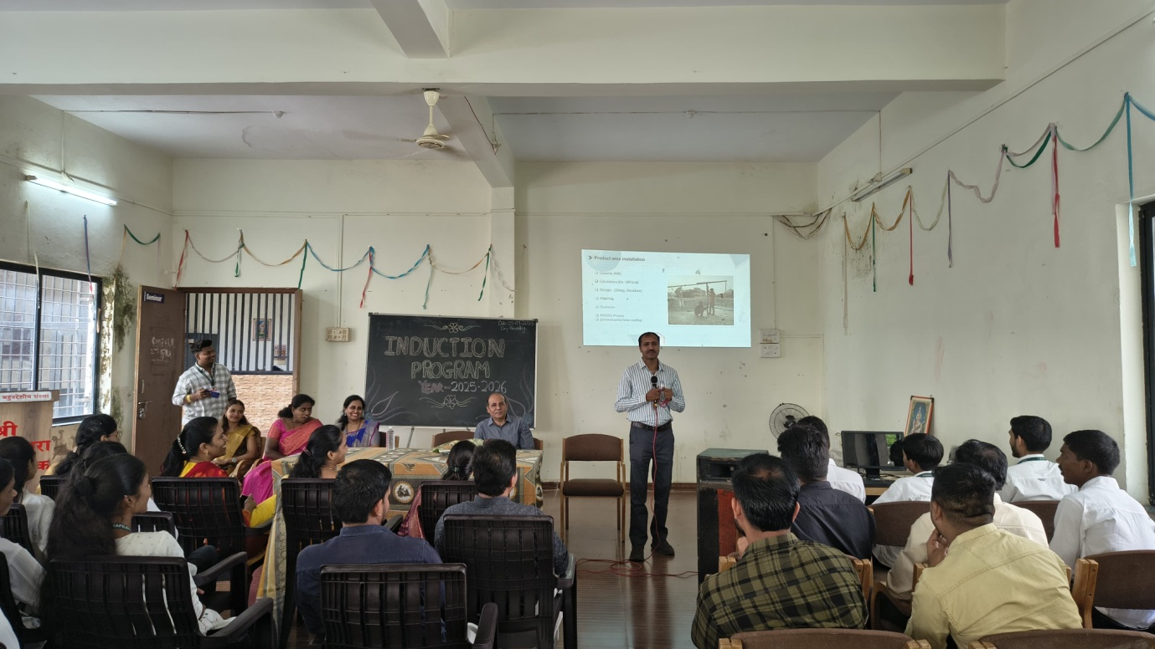

GUEST LECTURE ON ROOFTOP SOLAR SYSTEM

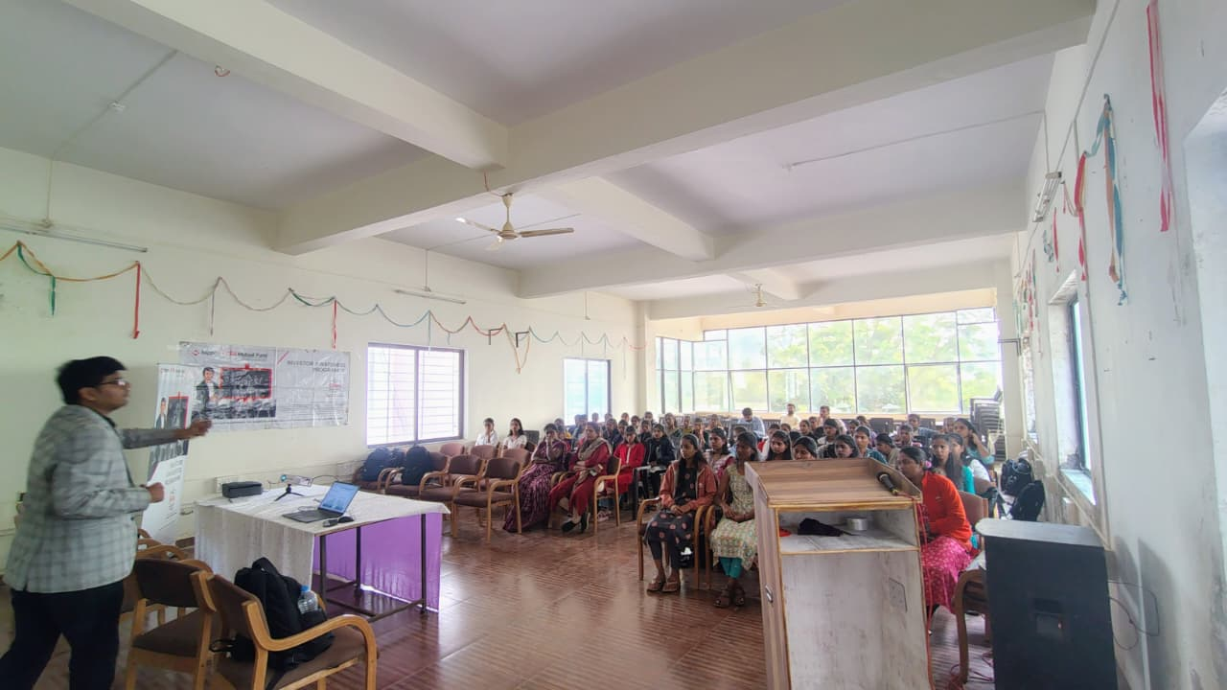

GUEST LECTURE ON FINANCIAL LITERACY

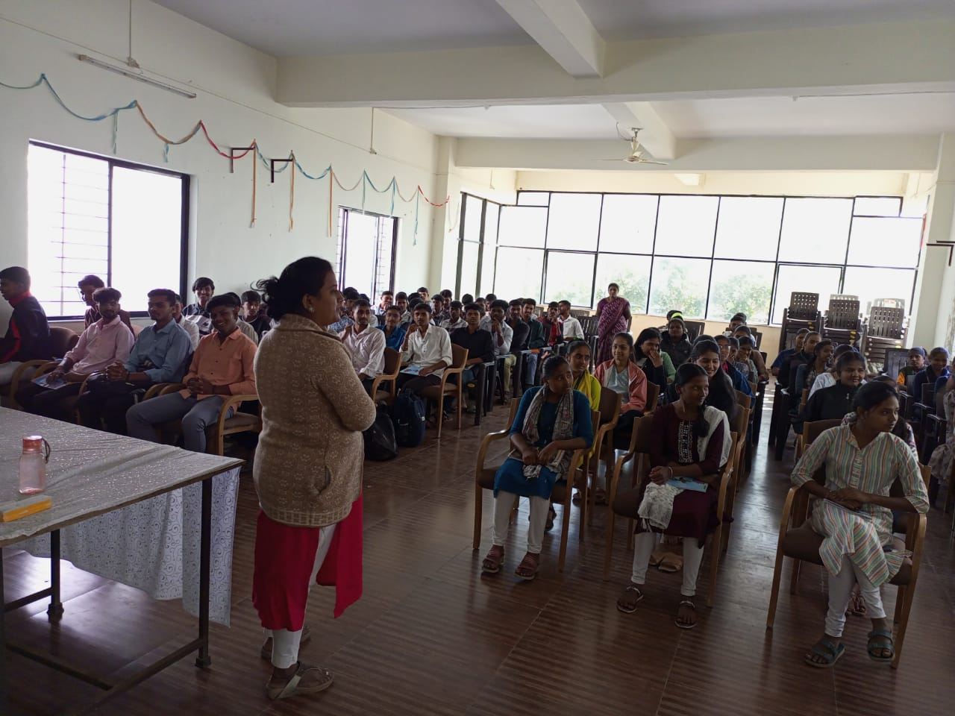

TWO WEEK TRAINING PROGRAM ON “ PERSONALITY DEVELOPLMENT”

